**CPE301 – SPRING 2019**

MIDTERM 1

Student Name: John Galanza

Student #: 5002981771

Student Email: galanj1@unlv.nevada.edu

Primary Github address:<https://github.com/JohnGalanza>

Directory: <https://github.com/JohnGalanza/supersmashjoe>

Submit the following for all Labs:

1. In the document, for each task submit the modified or included code (only) with highlights and justifications of the modifications. Also, include the comments.
2. Use the previously create a Github repository with a random name (no CPE/301, Lastname, Firstname). Place all labs under the root folder ESD301/Midterm, sub-folder named LABXX, with one document and one video link file for each lab, place modified asm/c files named as LabXX-TYY.asm/c.
3. If multiple asm/c files or other libraries are used, create a folder LabXX-TYY and place these files inside the folder.
4. The folder should have a) Word document (see template), b) source code file(s) and other include files, c) text file with youtube video links (see template).

1. **COMPONENTS LIST AND CONNECTION BLOCK DIAGRAM w/ PINS**

* Atmega 328p
* LM 35 temperature sensor
* FTDI chip
* female to male jumper wires
* breadboard
* laptop

1. **INITIAL/MODIFIED/DEVELOPED CODE OF TASK 1/A**

#define F_CPU 16000000UL

#define BAUD_RATE 9600

#include <avr/io.h>

#include <util/delay.h>

#include <avr/interrupt.h>

#include <stdio.h>

#include <stdlib.h> //all the headerss

void read_adc(void); //Function declarations

void adc_init(void);

void USART_init();

void USART_tx_string(char * data);

void USART_send(unsigned char ch);

void USART_print(char* str);

volatile uint8_t OVFCount;

volatile unsigned int adc_temp;

char outs[20];

int main(void)

{

adc_init(); //Initializes ADC

USART_init(); //Initialize USART

while (1)

{

ADCSRA|=(1<<ADSC);

while((ADCSRA & (1<<ADIF))==0);

ADCSRA |= (1<<ADIF);

int a = ADCL;

a = a | (ADCH<<8);

a = (a/1024.0)* 5000/10;

USART_send((a/100)+'0');

a = a % 100;

USART_send((a/10)+'0');

a = a % 10;

USART_send((a)+'0'); //converts the number

USART_send('\r');

_delay_ms(1000);

char setMUX[] = "AT+CIPMUX=0\r\n"; //Repeating the steps ESPlorer used

USART_print(setMUX); //Sends string to USART using USART_send to send each character of string

_delay_ms(1000);

char thingSpeakINIT[] = "AT+CIPSTART=\"TCP\",\"api.thingspeak.com\",80\r\n" ;

USART_print(thingSpeakINIT);

_delay_ms(1000); //add in delay to allow for proper interactions

char SENDthingSpeak[] = "AT+CIPSEND=80\r\n"; //saying we'll send more data than we actually will

USART_print(SENDthingSpeak);

_delay_ms(1000);

char GETthingSpeak; //sends data to thingSpeak

snprintf(GETthingSpeak, sizeof(GETthingSpeak), "GET https://api.thingspeak.com/update?api_key=R9HDZJDAPCP0G215&field1=0", a);

USART_print(GETthingSpeak);

_delay_ms(1000);

char thingSpeakClose[] = "AT+CIPCLOSE\r\n";

USART_print(thingSpeakClose);

_delay_ms(1000);

}

return 0;

}

void adc_init(void)

{

//set up and enable ADC

ADMUX = (0<<REFS1)| //Reference selection bits

(1<<REFS0)| //AVcc - external cap at AREF

(0<<ADLAR)| //ADC Left adjust result

(0<<MUX2)| //analog channel selection bit

(0<<MUX1)| //chooses pc5 pin28

(0<<MUX0);

ADCSRA =(1<<ADEN)|

(0<<ADSC)|

(0<<ADATE)|

(0<<ADIF)|

(0<<ADIE)|

(1<<ADPS2)| //prescaler

(0<<ADPS1)|

(1<<ADPS0);

}

void read_adc(void)

{

unsigned char i = 4;

adc_temp = 0;

while(i--)

{

ADCSRA|=(1<<ADSC);

while(ADCSRA & (1<<ADSC));

adc_temp += ADC;

_delay_ms(50);

}

adc_temp = adc_temp/4; //averages a few samples

}

void USART_init(void)

{

UBRR0L = 8;

UCSR0C = (1<<UCSZ01)|(1<<UCSZ00); //asynchronous 8 N 1

UCSR0B = (1<<TXEN0)|(1<<RXEN0); //enable receiver, transmitter & RX interrupt

}

void USART_send(unsigned char ch)

{

while(!(UCSR0A & (1<<UDRE0)));

UDR0 = ch;

}

void USART_print(char* str)

{

int i = 0;

while (str[i] != 0)

{

USART_send(stri[i]); //increments i to go through the whole string

i++;

}

}

//Sends data to serial port

void USART_tx_string(char *data)

{

while((*data!= '\0'))

{

while(!(UCSR0A & (1<<UDRE0)));

UDR0 = *data;

data++;

}

}

1. **DEVELOPED MODIFIED CODE OF TASK 2/A from TASK 1/A**
2. **SCHEMATICS**

Use fritzing.org

1. **SCREENSHOTS OF EACH TASK OUTPUT (ATMEL STUDIO OUTPUT)**

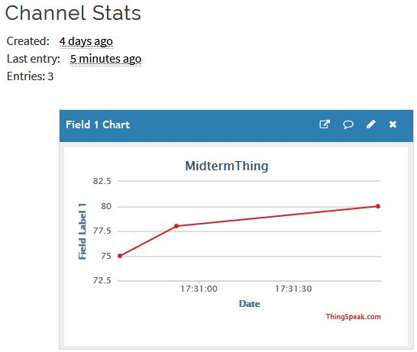

1. **SCREENSHOT OF EACH DEMO (BOARD SETUP)**

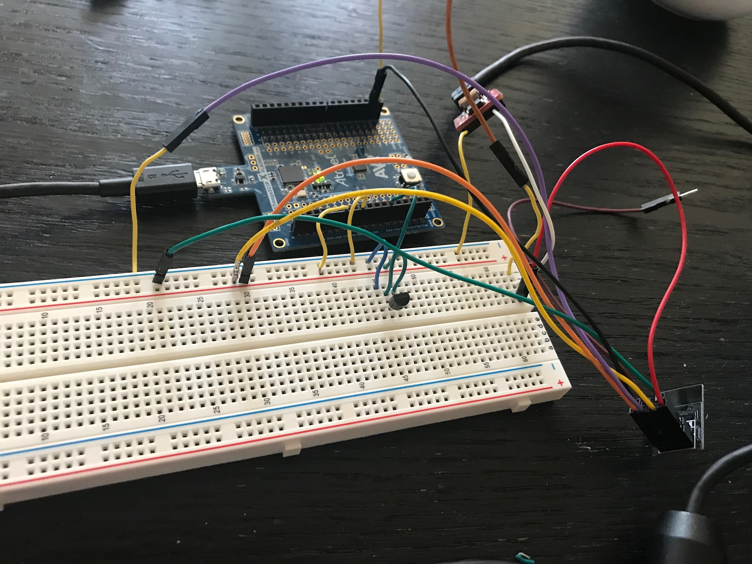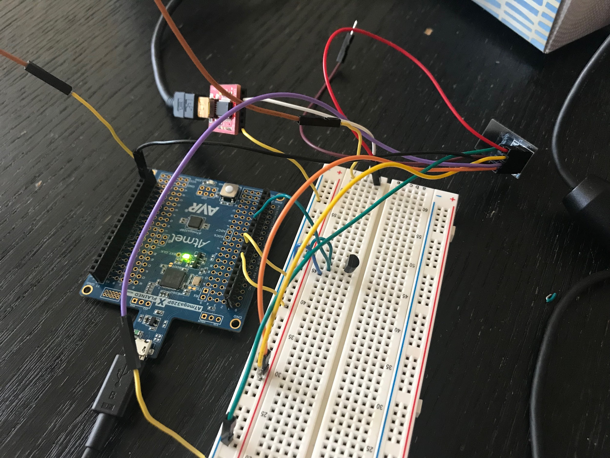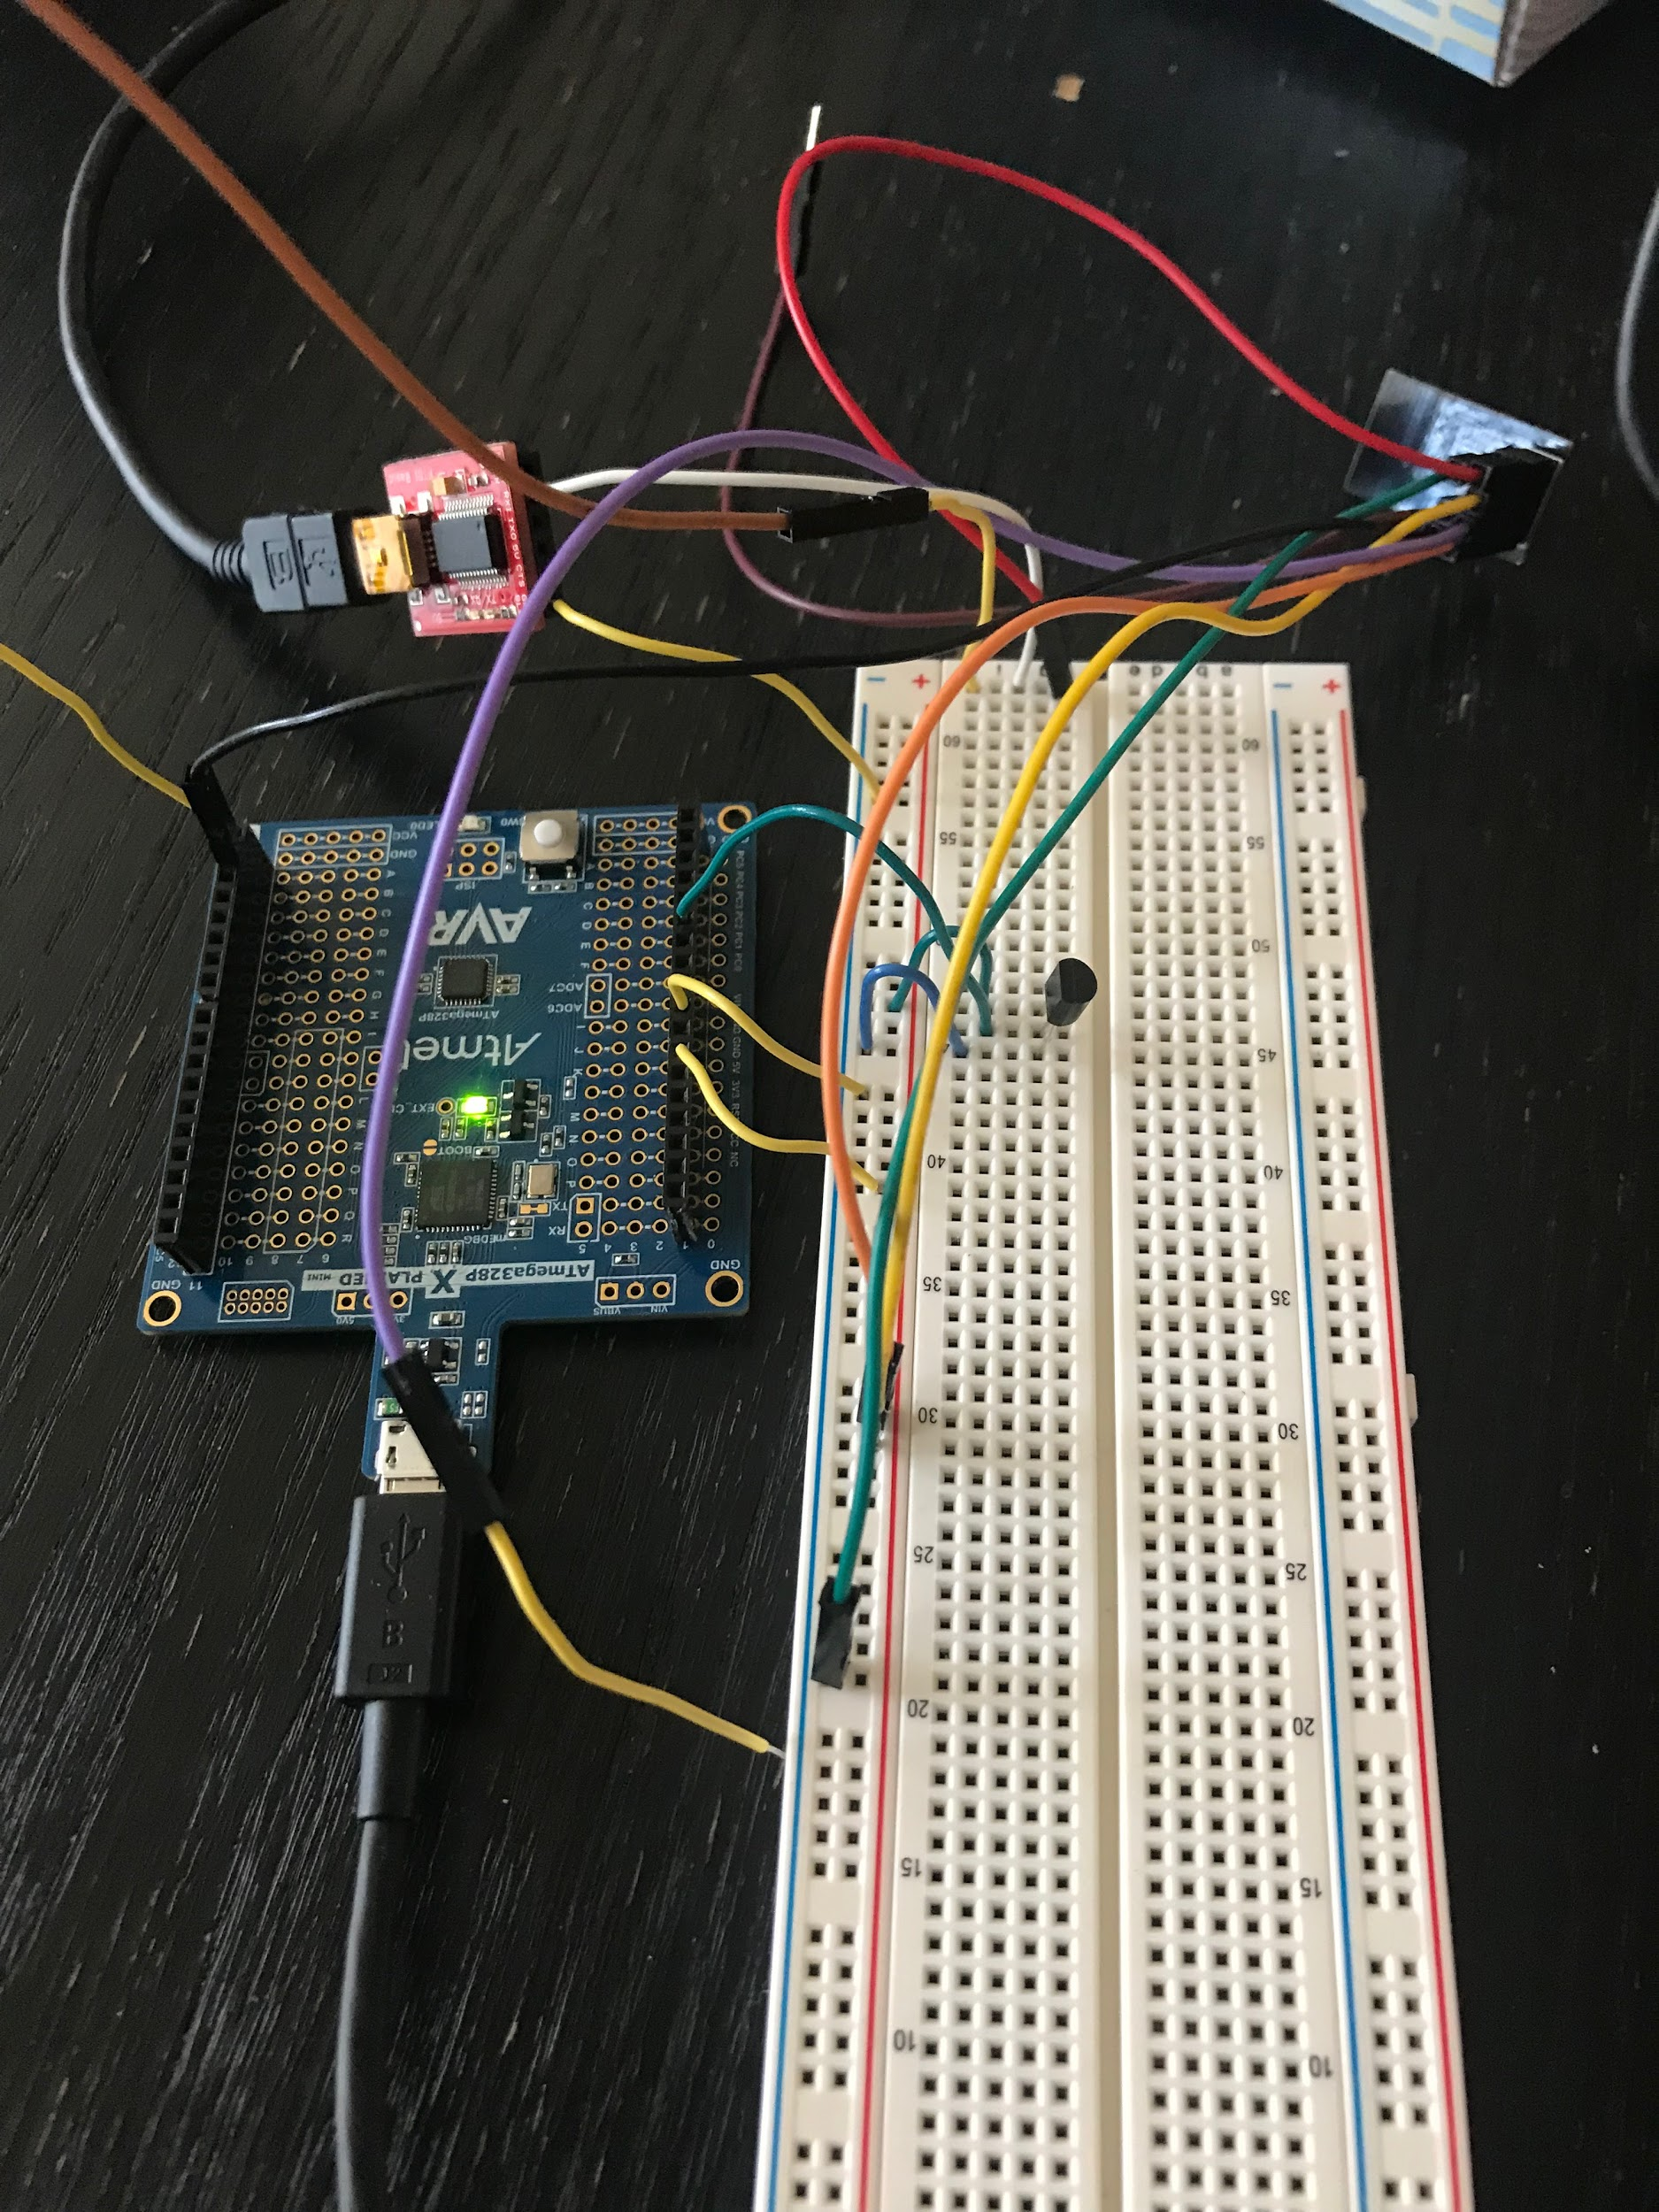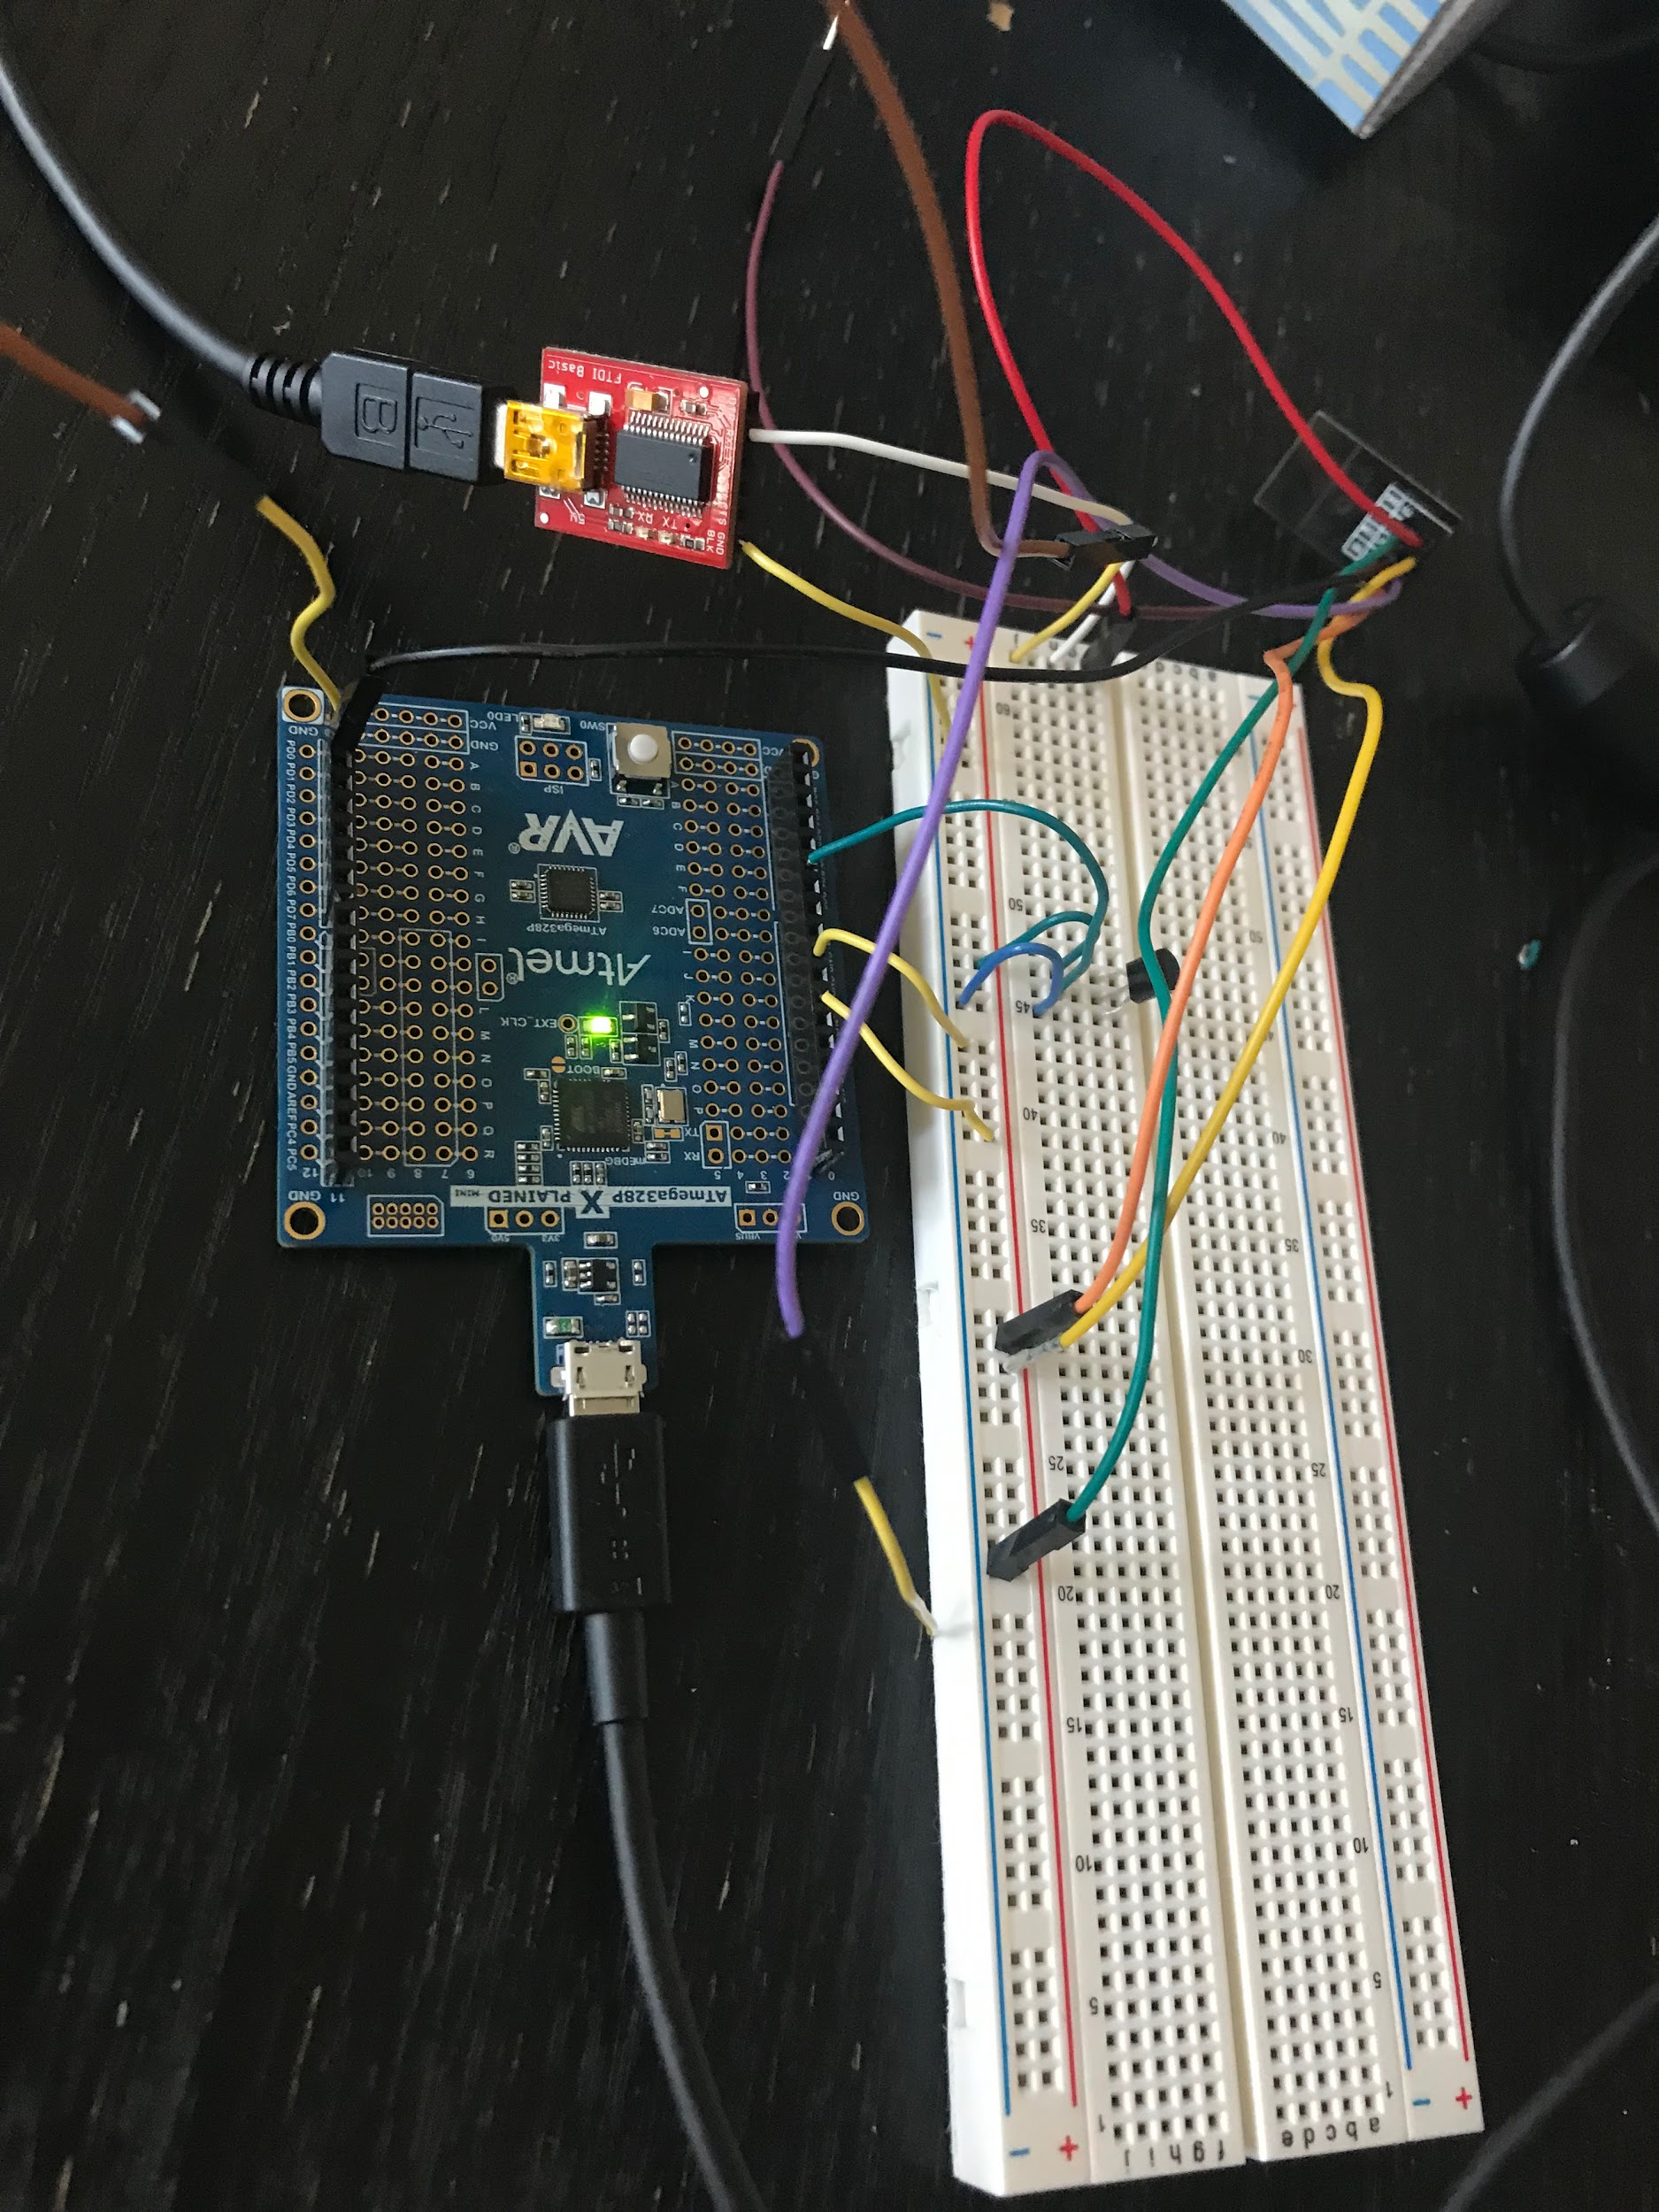

1. **VIDEO LINKS OF EACH DEMO**

<https://youtu.be/CVL937mhxgE>

1. **GITHUB LINK OF THIS DA**

<https://github.com/JohnGalanza/supersmashjoe/tree/master/Midterm%201>

**Student Academic Misconduct Policy**

<http://studentconduct.unlv.edu/misconduct/policy.html>

“*This assignment submission is my own, original work*”.

John Galanza